**AMERICAN INTERNATIONAL UNIVERSITY–BANGLADESH (AIUB)**

FACULTY OF ENGINEERING

Course name: Data Communication

Course code: COE 3201

Section: H

Semester: Spring 2023-24

Group-04

|  |
| --- |
|  |

|  |  |
| --- | --- |
| **NAME** | **ID** |
| EFFAT ARA | 22-46090-1 |
| MD. ABDULLAH SHISHIR | 22-46410-1 |
| FARJANA YESMIN OPI | 22-47018-1 |
| MD. ABU TOWSIF | 22-47019-1 |
| MOST. SAYMA KHATUN | 22-47035-1 |

Experiment No : 09

Experiment name: **Study of Frequency Modulation and Demodulation using (MATLAB)**

Submission date: April 26th, 2024

**ANSWER OF QUESTION 1**

Frequency Modulation (FM) is a modulation technique in which the frequency of the carrier signal is varied in proportion to the instantaneous amplitude of the modulating signal. In FM, the amplitude of the carrier signal remains constant while its frequency changes according to the variations in the modulating signal.

Advantages of Frequency Modulation (FM) over Amplitude Modulation (AM):

1.Improved Signal-to-Noise Ratio (SNR): FM is more resilient to amplitude variations and noise compared to AM. Since the information is encoded in the frequency variations rather than the amplitude, FM signals tend to have a higher signal-to-noise ratio, resulting in clearer reception, especially in environments with high levels of noise and interference.

2. Better Fidelity: FM offers better audio fidelity and sound quality compared to AM modulation. This is because FM preserves the original waveform of the modulating signal more faithfully, allowing for higher-fidelity reproduction of music and voice transmissions.

3. Constant Amplitude: In FM, the amplitude of the carrier signal remains constant, regardless of the variations in the modulating signal. This means that variations in the strength of the transmitted signal (due to changes in propagation conditions or interference) do not affect the quality of the demodulated signal, unlike AM where variations in amplitude directly impact the quality of the received signal.

4. Frequency Diversity: FM signals can be more easily separated in frequency domain compared to AM signals. This enables frequency diversity techniques, where multiple frequency channels can be utilized simultaneously without significant interference, thus increasing the capacity and efficiency of the communication system.

Overall, Frequency Modulation (FM) offers several advantages over Amplitude Modulation (AM), including improved signal quality, better noise performance, and greater immunity to certain types of interference, making it a preferred choice for many communication systems, particularly in applications where high-fidelity audio transmission or reliable data communication is required.

**ANSWER OF QUESTION 02**

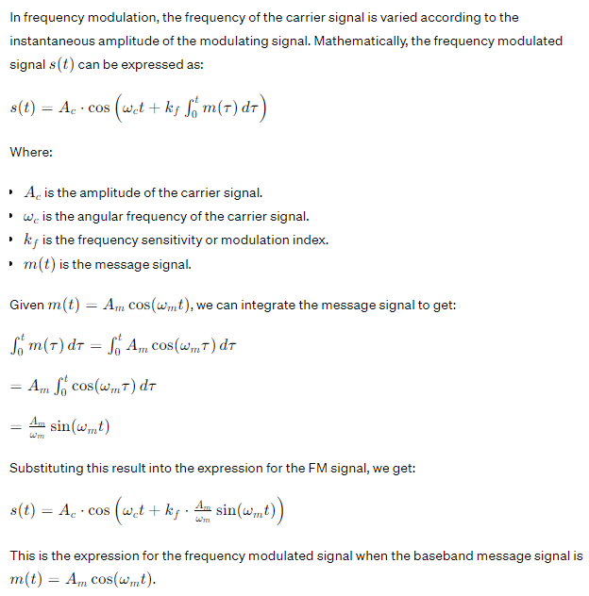

|  |  |
| --- | --- |
| MATLAB Code  **ANSWER OF QUESTION 03** | Output Figure |
| clc;  clear all;    fc=100; % frequency of the carrier signal  fm=20; % frequency of the modulating/baseband signal    fs=1000; % sampling frequency  t = 0:1/fs:1-1/fs; % time domain range  A = 10;  M=A * cos(2*pi*fm*t);% modulating signal/message signal/baseband signal    c= A * sin(2*pi*fc*t); %carrier signal    fms =sin(2*pi*fc*t+2.*sin(2*pi*fm*t)); %FM modulated signal    fmdemod=2.*fmdemod(fms,fc,fs,(fc-fm)); % FM demodulated signal    subplot(4,1,1);  plot(t,M);  ylabel('amplitude');xlabel('time');title('Modulating/Baseband signal');    subplot(4,1,2);  plot(t,c);  ylabel('amplitude');xlabel('time');title('Carrier signal');    subplot(4,1,3);  plot(t,fms);  ylabel('amplitude');xlabel('time');title('Frequency Modulated signal');    subplot(4,1,4);  plot(t,fmdemod);  ylabel('amplitude');xlabel('time');title('Demodulated signal');    fftSignal = fft(fms);  fftSignal = fftshift(fftSignal)/(fs/2);  f = fs/2*linspace(-1,1,fs);    figure;  stem(f, abs(fftSignal));  title('FFT of FM modulated signal');  xlabel('Frequency (Hz)');  ylabel('magnitude'); |  |